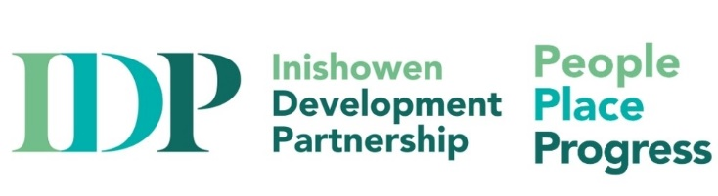

Job Description

Ukrainian Support Workers (Part-time) Sept – Dec 2022

Introduction: IDP is adapting their team to ensure we underpin our people-centred approach and address disadvantage and social exclusion. With the unprecedented influx of Ukrainian nationals to Ireland, and to ensure a coordinated national humanitarian response to people fleeing conflict in Ukraine and seeking protection in Ireland, IDP, as part of the Government response want to hire Bilingual Integration Support Workers providing one-to-one supports and advocacy. We welcome and encourage applications from bilingual Ukrainians with fluency in English that have been granted Temporary Protection in Ireland. We are recruiting for up to three part-time positions. These staff will work closely and collaboratively with key stakeholders to ensure an effective implementation of the emergency response programme and will ensure they meet and follow international best practice.
Main purpose of job:

Based in the IDP Buncrana Office/remotely within Inishowen Ukrainian Hubs, the job holder will report to Inishowen Development Partnership’s (IDP) Joint CEO and the Board of IDP.

Duties of the post:
- Provide one-to-one support on a variety of areas affecting newly arrived migrants to Inishowen and co-ordinate day to day activities, include providing advice, guidance and translation supports where necessary
- Work closely with various Interagency Fora and IDP Local Area Response team, and collaborate with the local community to coordinate and deliver programmes to migrants where applicable to the role
- Providing information and access to IDP’s range of education, enterprise and employment, health and wellbeing, children and families supports. Assist in the overall delivery of SICAP services and supports, by providing interpretation and translation services.
- To provide culturally appropriate information, and understand the barriers to integration that exist for some migrants and study appropriate mechanisms for over-coming these barriers
- To develop and maintain, with the support of colleagues, an accurate understanding of the relevant immigration legislation and policies relative to asylum seekers and refugees
- Attend and contribute to LCDC Subgroup Meetings as required and internally to IDP Team meetings. To work collaboratively with other organisations and networks where appropriate, both locally and nationally
- Maintain up-to-date files and records, preparing periodic reports as required.
- Ability to travel regularly throughout the service delivery area.
- To maintain strict confidentiality of personal information about service users and adhere to IDP policy and procedure in this regard.
- Other related duties as required by the needs of the project

Person Specification

Qualifications:
- A relevant third-level qualification including social sciences/social care, psychology, community development or equivalent combination of relevant education and experience;
- Have verbal and written fluency in English and Ukrainian.
- Successful candidates must continue to satisfy Citizenship Eligibility requirements (including any person holding an official letter confirming they have been granted Temporary Protection in Ireland under the EU Temporary Protection Directive 2001/55/EC)
- Ukrainian and Russian language fluency essential.
- Fluent in English (written and oral)

Experience/Knowledge:
- A minimum of one year experience in a similar position or in community services/education/social care setting
- Experience of providing individual support and outreach, preferably to migrants/refugees/asylum seekers
- Some understanding of immigration policies, practices and legislation in Ireland
- A strong interest in and knowledge of the issues facing asylum seekers and refugees and migrants in Ireland, particularly those who are at risk of social exclusion, poverty and discrimination
- A commitment to a human rights-based approaches
- Knowledge of social welfare policies and practices
- Experience of report writing
- Experience in information provision and advocating for rights and equality
- An understanding and ability to relate to and work with people across cultures and backgrounds
- Experience of working in partnership with a wide range of other organisations

Skills/Abilities:
- Ability to engage with our client group with compassion and empathy
- Highly organised, with the ability to work well under pressure
- To have a flexible and adaptable work approach
- Excellent organisational and time management skills
- Excellent written, verbal, analytical and interpersonal skills
- Exercise good listening and communication skills with sensitivity to cultural communication skills
- Appreciation of the need for confidentiality and integrity
- Well-developed IT skills
- Effectively work as a team member and independently, with a high-level of self-motivation and ability to set and meet goals
- Comfortable working in a busy, dynamic, multi-cultural environment
- A full current clean driving licence and access to a car is desirable
- Evening and/or weekend work may be required

How to Apply: Applications only on IDP’s official application form to enquiries@inishowen.ie stating clearly that it relates to the ‘Ukrainian Support Worker’ role. Only those who complete the official application form will be considered for the position. Closing date for applications: Monday, August 8th, 1pm. All applicants should note that the proposed interview date is Tuesday August 16th. Interviews may be via zoom or in person.
Job start date will be week commencing September 5, 2022.

Inishowen Development Partnership is an equal opportunities employer and welcomes applications from all sections of society. The appointment is subject to normal recruitment procedures including Garda/Police Vetting
