
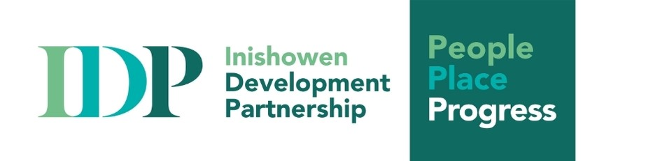
Community Employment (CE) Supervisor for
Health & Social Care CE Programme
Introduction: In line with our commitments to people, place and progress, to growing as a responsive organisation and to our duty of care to clients, staff and volunteers, Inishowen Development Partnership (IDP) is recruiting for a new position within this growing and diverse team.
Main purpose of job: The role of the Community Employment Supervisor is a fast-paced role within IDP, focusing on the effective and efficient management and co-ordination of the human, financial and material resources of the CE Scheme and reporting to the Sponsoring Committee on its implementation.
The role includes an outreach service covering the wider Inishowen area. Reporting to the Joint CEO, this role will work with our Employment and Enterprise Support Team, ensuring that emerging needs are identified and planned for, and client needs are responded to in a timely and effective way.
To be successful in this role, you should be knowledgeable of the Health & Social Care sector with a core aspect of the role being to support and coach the CE participants in gaining the skills, competence, and qualifications in preparation for employment. The job will involve:
- Ensuring the effective and efficient management and co-ordination of the human, financial and material resources of the CE Scheme including reporting to the Sponsoring Committee on its implementation
- Supporting and Coaching CE participants towards gaining the skills, competencies, and qualifications in preparation for employment.
- Ensuring the provision of an efficient financial and accounting and claim system in line with CE corporate governance requirements as directed by the Sponsoring Organisation and in compliance with the standards laid down through the Welfare Partners system.
- Processing prompt and accurate payment of participant allowances.
- Installing and managing effective time keeping record system for participants on the scheme.
- Liaising with the local Department Officers as required.
- Carrying out an identification of learner needs with individual participants as required as part of the Individual Learner Plan process and preparing an Individual Learning Plan (ILP) for each Participant as well as entering same on Welfare Partners in accordance with CE procedures.
- Reporting on ILP (Individual Learning Plans) developments to Sponsoring Organisation
- Identifying needs and sourcing and coordinating cost effective training/development opportunities in line with Department procurement guidelines.
- Facilitating access to recognised qualifications for participants, with a focus on the achievement of relevant qualifications including Major Awards on the National Framework of Qualifications (NFQ) or industry related standards
- Planning and procuring relevant training opportunities which have been approved by the Department.
- Maintaining and updating training records for each participant on the project on Welfare Partners as part of their Individual Learner Plans.
- Monitoring and reviewing training inputs with the participants.
- Planning and organising work placements internal and external as required.
- Supporting the management of a Department of Social Protection (DSP) client caseload system and maintain IDP’s and other Customer Relationship Management (CRM) systems, as directed.
- Maintaining caseload records and building a case-study portfolio and general statistical information.
- Undertaking other duties and responsibilities as may be assigned in agreement with the CEO and/or Board of Management.
Person Specifications: This role will require a wide range of abilities and skills including: -
- Experience and knowledge of the health and social care sector.
- Commitment to and understanding of working within a community organisation in an inclusive manner.
- High motivation, positive disposition, and flexible attitude in response to organisational change and development
- Methodical and diligent with outstanding planning abilities
- An ability to think strategically about the information that will help stakeholders make informed decisions and to communicate the value of this information effectively.
- A positive motivational mindset and an inclination for problem-solving.
- Ability to write comprehensive documents with a sharp attention to accuracy and detail.
- A team player.
- Strong verbal and written communication skills.
Experience and knowledge of: -
- HR and Recruitment Practices
- Database and spreadsheets
- Report writing and excellent writing skills
- Reporting procedures and record keeping

 | Essential | Desirable
Knowledge and Skills
Third level Qualification (NFQ Level 6 or higher) in Health & Social Care, Business/Financial, Administration, Training,
Human Resources, Project Management or related disciplines.

Knowledge and experience of the sector, ideally 3+ years
Knowledge of HR Procedures
Knowledge and experience of managing budgets.

Excellent organisational skills, including the capacity to manage complex tasks, work independently and work to deadlines.
Strong IT skills- proficiency in all Microsoft Office applications and ability to present data in a range of formats and to various audience.
Empathetic to the needs of those most distanced from the labour market - The ability to work sensitively and in an empowering way, maintaining confidentiality, dignity and respect,

Flexible, creative with the ability to adapt to a changing and challenging environment.
Experience
Supervisory experience of managing a team, ideally 3+ years.
Experience with working with the long-term unemployed
Experience of organising Training for the target group with diverse needs
Experience of writing documents, in an accessible format, to publication standard
Competencies
Adaptable and Responsive – pays attention to detail and searches for solutions
Demonstrate good IT skills and Public Relations experience
Collaborative
Develops positive relationships with others internally and externally to achieve goals
Shares information effectively and frequently
Leadership
Provides feedback and encouragement to others and supports problem solving
Implements suggestions for improvement and takes accountability for own performance
Communication
Excellent verbal and written communication skills
Planning and Innovation
Identifies clients and stakeholder needs and develop ideas on how to meet them
Develop funding proposals to source additional programmes suitable for clients
A full current clean driving license and access to a car is essential
Evening and/or weekend work may be required

How to Apply: Please complete the official application form and send, accompanied by an up to date CV and a cover letter outlining why you would like to join our team to enquiries@inishowen.ie stating clearly that it relates to the ‘Community Employment (CE) Supervisor’ role.
Closing date for applications: Wednesday 18th October at 12 noon
Salary scale for this position is based on DSP’s CE Programme rate: - €34,257.60 pro rata. Shortlisting will apply and a panel may be formed.
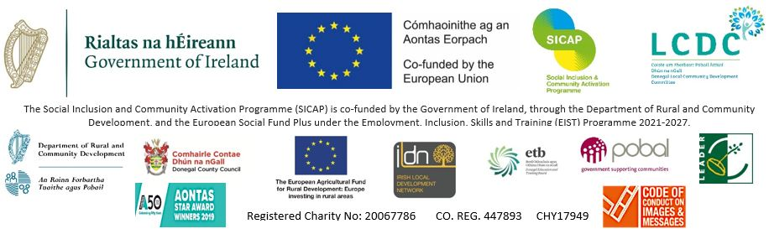
Inishowen Development Partnership is an equal opportunities employer and welcomes applications from all sections of society. The appointment is subject to normal recruitment procedures including Garda/Police Vetting.

