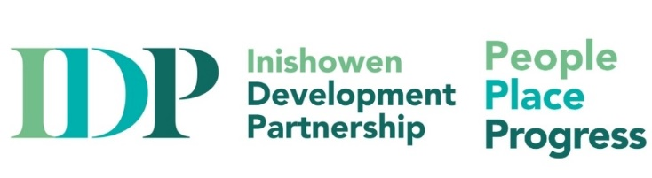

Community Facilitator for Defective Concrete Blocks Scheme – (Full-time)
Supporting our community is integral to the work that we do with the goal of having empowered, thriving and flourishing communities across Inishowen now and into the future in IDP. In line with our commitments to people, place, and progress, as a responsive organization, and to our duty of care to clients, staff and volunteers, supported by the Department of Housing, Local Government & Heritage, through Donegal County Council, Inishowen Development Partnership (IDP) is recruiting for a Community Facilitator for the Defective Concrete Blocks Scheme(DCB).
Main purpose of job: The DCB Community Facilitator will be responsible for supporting and guiding the homeowner through the application process, facilitating access to relevant support services . Based in the IDP Offices, but with outreach functions across the peninsula including public events and clinics, the job holder will report to Inishowen Development Partnership’s (IDP) Joint CEO and the Board of IDP and will liaise closely with the Council’s Defective Concrete Block Grant Team.

The duties of the DCB Community Facilitator will include:
To provide facilities for homeowners who may not have the necessary facilities to make an online application e.g. scanning, printing of necessary forms.
To provide assistance to homeowners in accessing the necessary supporting documentation required to make an application, such as Land Registry, Revenue Commissioners, Engineer’s Ireland, and so forth.
To signpost homeowners in accessing other services, such as health services, counselling services and other services / programmes that are developed.
To support homeowners in negotiations with financial institutions in relation to existing mortgages and borrowings.
To support homeowners securing alternative accommodation, if required
To support homeowners to secure storage facilities, if required.
To liaise with the DCB Community Facilitator in the Inishowen Development Partnership (IDP) and work in partnership with the Donegal County Council’s Defective Concrete Block Grant Team.
To prepare for monthly meetings, solve problems and share information so all parties have a full understanding of any challenges being experienced in their respective roles.
To apprise the CEO on progress to ensure that the role of the DCB Community Facilitator is in line with expectations. To prepare ongoing activity reports on projects for presentation to the working group, and other relevant stakeholders.
As outputs and outcomes will be reviewed against KPI’s on a quarterly basis, the DCB Community Facilitator will be required to prepare timely reports on the process of the Scheme.
To undertake other duties as directed by the Joint CEO or Board of Management.
Ensure confidentiality is maintained at all times.

Essential Criteria
- A minimum of a BSc/BA in Community Development, Business, Social Science or related field
- A minimum of 3 year’s experience of working in an information, advice, advocacy or community development setting.
- Dynamic interpersonal and communication skills, the ability to network, liaise and negotiate with local groups, agencies and banking institutions to form positive working relationships with local community group committees, stakeholders, and funders.
- They will be required to act as a positive problem solver with empathy and good listening skills and be contributing member of the wider staff team within IDP
- Excellent organisational, administrative and a good working knowledge of the standard suite of business- related software and IT packages is essential
- An understanding of the issues around the provision of, and access to information, advice and advocacy services.
- Understanding of schemes available for the Remediation of Damaged Dwellings due to Defective Concrete Blocks.
- A full current clean driving licence and access to a car is essential
- Evening and/or weekend work may be required

How to Apply: Applications only on IDP’s official application form to enquiries@inishowen.ie stating clearly that it relates to the ‘DCB Facilitator’ role. Only those who complete the official application form will be considered for the position. Closing date for applications: Monday, September 9th 12 noon. All applicants should note that the proposed interview date is Tuesday September 17th in the Buncrana IDP office.
Salary scale for this position is €46,411 per annum pro rata.

The post holder will be employed initially on a one-year contract with the option to extend the contract subject to satisfactory performance, reporting structures and funding availability.

Inishowen Development Partnership is an equal opportunities employer and welcomes applications from all sections of society. The appointment is subject to normal recruitment procedures including Garda/Police Vetting

