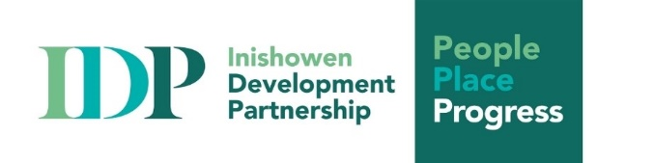

Grant Programme for Local Community Groups

Guidance Notes for Applicants

Enclosed/attached please find the application form for funding under the Social Inclusion Community Activation Programmes (SICAP) 2024-2028: Goal 1 - Small Grants Programme.

To help you decide if your group can avail of funding from the Inishowen Development Partnership (IDP), below is listed the relevant goal of the SICAP programme. Actions of IDP are expected to further at least one of the SICAP Goal 1 objectives. Any group intending to apply for this grant funding should ensure that their project will promote SICAP Goal 1. The purpose of the grant must be in line with the objectives of the programme and there must be a clear outcome in line with SICAP objectives.

Please take a few minutes to read these short guidance notes and pay particular attention to the goal set out below. If you are unsure of the meaning of anything in this document, please contact a member of our Community Development Team (contact details are on Page 3).

Please note under the SICAP 2024-2028 programme, only Social Enterprises that are micro-enterprises are eligible to apply for this funding. Micro-enterprises contain fewer than 10 employees.

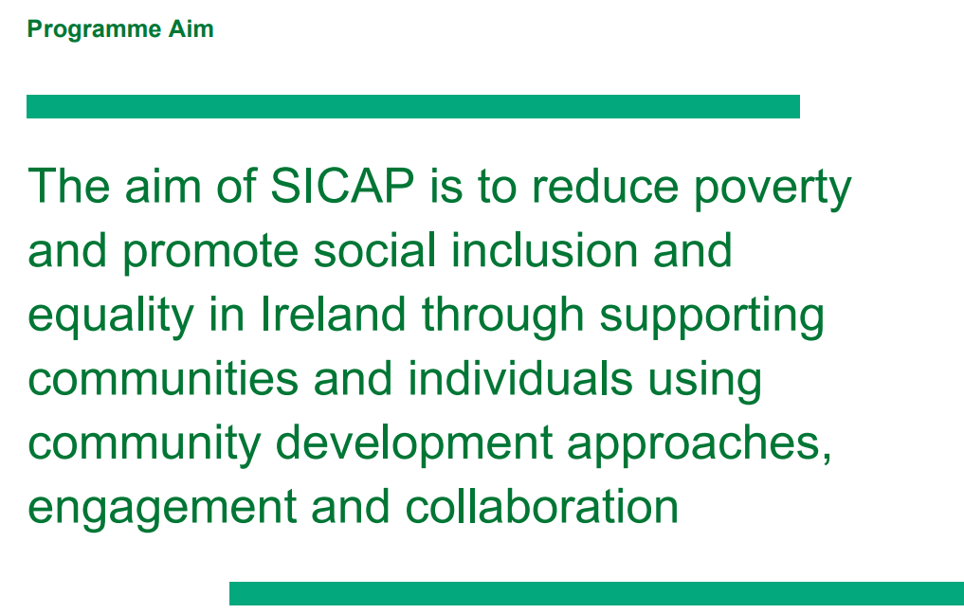

The proposed project of applicant groups should fall under Goal 1.

Goal 1: Contribute to Building more Sustainable, Inclusive and Empowered Communities
To support communities and target groups to engage with relevant stakeholders in identifying and addressing social exclusion and equality issues, developing the capacity of Local Community Organisations, and creating more sustainable communities.
SICAP 2024-2028 is underpinned by four Horizontal Principals:
1. Promoting a human rights and equality framework, with a particular focus on gender equality and anti-discrimination;
2. Applying quality community development approaches to achieve the participation of disadvantaged and marginalised communities in society, as well as within the SICAP programme itself and the wider local development context, and combatting poverty as an obstacle to social inclusion and economic progression;
3. Developing collaborative approaches with stakeholders to identify and fill gaps in services for SICAP target groups and improve how mainstream 21 policies and programmes are delivered so they impact more positively on the socially excluded; and
4. Promoting Climate Justice, with a focus on facilitating a just and equitable transition to a greener economy and society.

Target Groups
The applicant group should include members of at least one of the target groups and/or thematic areas listed in the application form.

The overall programme is aimed at:
People living in disadvantaged communities  Disadvantaged Women |  | Older People in isolation
People impacted by educational disadvantage |  | Refugee and Migrant Rights Integration
People living in jobless households where primary income is low-paid or precarious |  | Climate Action and Just Transition
People with criminal history |  | Addiction
Refugees |  | Homelessness
International Protection Applicants |  | LGBTQI+
People with Disabilities |  | Youth
Heads of One Parent Families |  | Gender
The Travelling Community
Roma

This September 2024 grant round is focused on Integration Supports for New Communities:
Therefore, please note the target groups/thematic areas for this fund are:
Refugees/International Protection Applicants/Refugee and Migrant Rights Integration

Outcomes of the Project/Numbers who benefit
It will strengthen an application if there are identified target numbers and tangible results expected, and that the group is clear on who will benefit and how.

Completing the Application Form
All the questions on the application form are important and are asked to ensure that the information we ask from you matches the information that we in turn are required to submit to our funding bodies. It is important to answer all questions as fully as possible giving all relevant information. This helps IDP assess your application.

Assistance to Application Groups
Every effort has been made to present this application form in clear English so that it is easy to complete by the applicant. Nevertheless, we appreciate that there can be difficulty with the application form. We will be happy to provide clarification and answer any questions that may arise and can also speak with applicant groups experiencing any difficulty in filling out the form. This does not guarantee funding. All applications are reviewed by a panel.

Assessment of applications for funding
The Inishowen Development Partnership will assess applications based on information supplied within the application form. As stated above, questions on the form are designed to gain a good understanding of your submission and relevant details needed to decide the merits of the application. The national SICAP rules apply (see below section). The assessment process is seeking to determine if the project is realistic, can be delivered on time, is budgeted properly, and is in line with SICAP Goal 1. Therefore, it is very important to complete all sections of the form.

Please note that there is a small budget in place for these grants, and a large number of applications is expected, so funding is not guaranteed.

Under IDP’s grants programme, given the local high level of demand, successful applicants can usually expect amounts of up to a maximum of €500. All decisions about funding applications are made by the Board of the Inishowen Development Partnership. Applicants will be informed of the status of their application after the April meeting of the Board.

For further information contact IDP by phone: 074-9362218

Community Development Team members below:
Name: Email:
Aine McLaughlin aine@inishowen.ie
Tracey McRory tracey@inishowen.ie
Barry McLaughlin barry@inishowen.ie

Administrator:
Rachel Grant rachel@inishowen.ie

Deadline for Application Submission: Monday 30th September at 5.00pm

National SICAP Guidelines

Activity Types for Local Community Group (LCG)/Community Organisation (CO) Grants
- Grants can be used to fund the following types of activities:
- The establishment of good governance structures within LCG/COs;
- The development of a community strategic plan to engage with other funders and stakeholders;
- Small-scale capital items that will improve and enhance the function of the LCG/CO and its work;
- Small-scale capital items that have a higher cost than €500 and where there is evidence that match funding is in place;
- Capacity building work with CO/LCG;
- Community activities that have a clear link to SICAP target groups and SICAP outcomes. These activities must show how they are part of an overall strategy to improve the quality of life for community members;
- Costs of travel and subsistence for LCG/CO members to enable them to participate in regional and national networking and learning opportunities where there is no other source of core funding available to the community organisation members;
- Funding to women’s groups, men’s sheds, homework clubs, youth work initiatives, after- school programmes delivered by LCG/COs etc. are eligible as long as the funding is allocated to a specific activity that focuses on SICAP target groups and is linked to an action in the SICAP annual plan.

Grants cannot be used to fund the following types of activities:
- Travel and subsistence for employees of other service providers that are a member of boards of management of LCG/COs or have a role in projects led by LCG/COs;
- Grants to statutory service providers operating breakfast clubs and homework support programmes;
- Funding for on-going running costs incurred by LCG/COs for example rent, insurance, electricity, phone costs and office maintenance.

