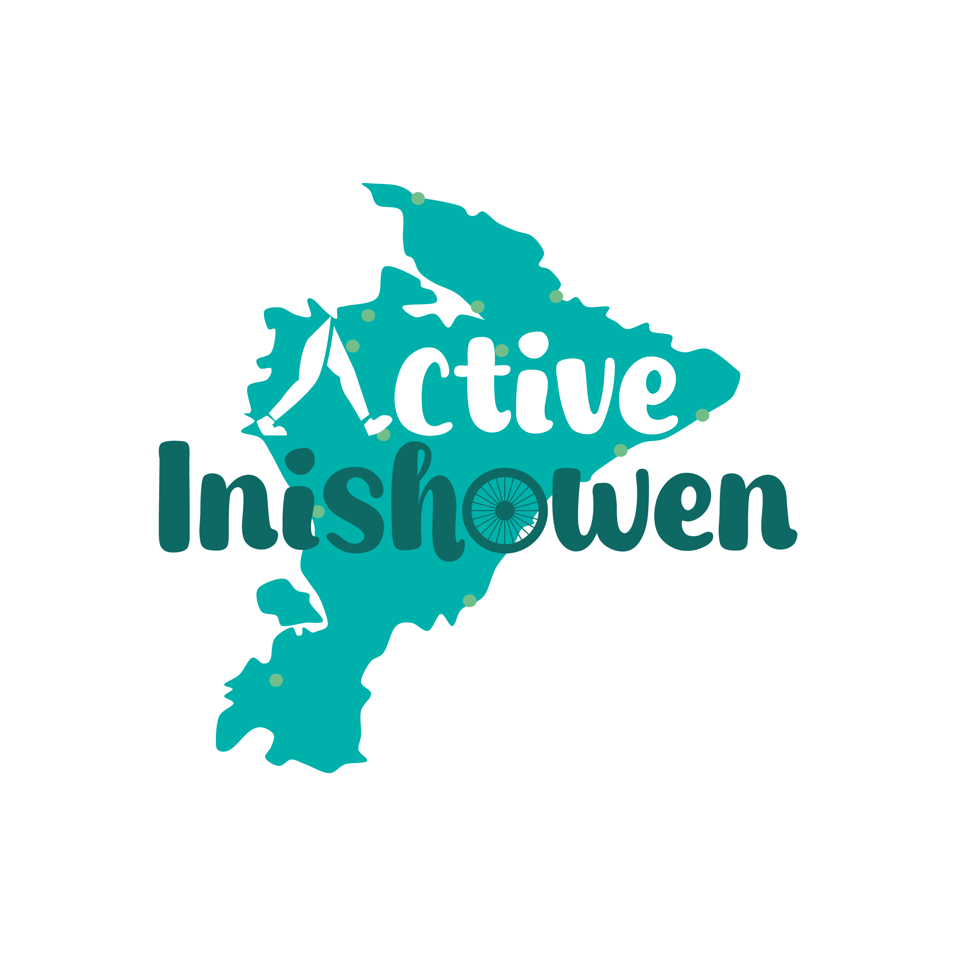

Active Inishowen: Lowland Leader Training Application Form
Thank you for your interest in the Lowland Leader Training Course facilitated by the Active Inishowen Project. This application form will help us select participants for this exciting training opportunity. Please complete all sections and submit the form by the application deadline of 1.00pm on October 8th 2024.
Note: Participation in the introductory day does not guarantee selection for the full training.

Section 1: Applicant Details
1. First Name: Surname/Last Name:
2. Address:
Eircode:
3. Email Address:
4. Phone Number:
5. Date of Birth:

Section 2: Experience and Interest in Lowland Leader Training
1. Briefly describe your interest in the Lowland Leader training and why you would like to participate in this course:

2. Please provide details of your walking experience (e.g. other training, number of walks, types of terrain, any leadership experience):

3. How do you envision using the Lowland Leader qualification in the future? (e.g. leading walks for the Active Inishowen Project, personal development, professional use):

Section 3: Availability
1. Are you available to attend the Introductory Day on October 13th, 2024? (Yes/No)

2. Are you available for the Lowland Leader Training on November 16th & 17th, 2024? (Yes/No)

Section 4: Commitment
- As a certified Lowland Leader, you will be expected to lead 3-5 walks annually for the Active Inishowen Project. (There will be a fee for delivery.) Do you agree to this commitment? (Yes/No)

Section 5: Additional Information
- Please share any additional information you feel is relevant to your application:

Submission Instructions
Please ensure all sections of this form are completed before submitting. Completed application forms should be sent via email to kevin@inishowen.ie no later than Tuesday 8th October 2024 at 1.00pm.

