


INISHOWEN DEVELOPMENT PARTNERSHIP

Important
You can either print out this application form and complete with black pen, or use Adobe Acrobat to complete this form electronically.

Instructions on completing application form electronically:

- Save the document to your computer
- Fill in all relevant text areas
- Save your application as you complete each section
- Once completed, attach the PDF to an email and return to ALONG your CV to enquiries@inishowen.ie

Note: Apple MAC users, do not use Preview to complete this form, thank you







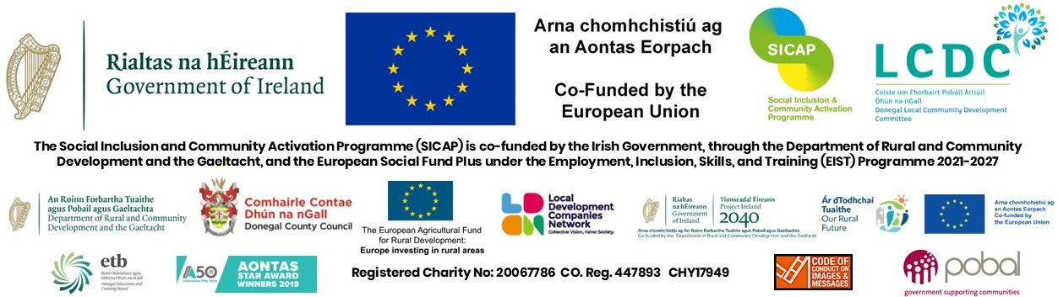

ChangeMakers Project Worker (P/T)

This Application Form, when completed, should be returned with your CV and cover letter to:

by email to HR@inishowen.ie

Closing Date: 1.00 pm on: March 2nd, 2026. Proposed interview date Thursday, March 12th

Surname (Block Capitals):- ______________________________________

First Name (Block Capitals):- ______________________________________

Address (for correspondence):-____________________________________

_____________________________________________________________

Permanent Address (if different):- _________________________________

_____________________________________________________________

Telephone No:- Home: ________________Work: ____________________

Mobile: ______________ E-mail Address: _____________

Please note interviews will be in person at IDP Buncrana (F93EE39). Do you require any special facilities/arrangements if called for interview: YES / NO
If yes, please specify:

How did you hear about this position:

Word of Mouth Local Newspaper IDP Website IDP Job Club

Intreo Social Media(Facebook))

Do you hold a full driving licence? ____________________________________

Do you have access to a car? ____________________________________

PARTICULARS OF EDUCATION

- EDUCATION/QUALIFICATIONS OBTAINED

School, College, University attended | Period  From To  (Please indicate if Full-Time or Part-Time) | Examinations taken indicating which level e.g Level 7, 8 etc  (with dates) | Results (Grade Obtained 1, 2.1 …Pass)

RECORD OF EMPLOYMENT EXPERIENCE TO DATE

Employer | Period of Employment  To From and Reason for Leaving | Position Held | Duties/Responsibilities
N.B. PLEASE COMPLETE PAGE NUMBERS 3 & 4 IN FULL.

RECORD OF EMPLOYMENT EXPERIENCE TO DATE

Employer | Period of Employment  To From and Reason for Leaving | Position Held | Duties/Responsibilities

N.B. PLEASE COMPLETE PAGE NUMBERS 3 & 4 IN FULL.
PLEASE ALSO SUBMIT A CURRICULUM VITAE

Details of Relevant Experience

In relation to the employment record you have supplied please give details of your experience in the following areas. You should ensure that the example(s) you use is from a recent period in your employment which you feel most equips you for this position.
1. Outline your experience of Community Development/Community Education and working with local groups.

2. Outline your knowledge and experience of Development Education, Global Citizenship, Social Justice, and Sustainable Development

3. Please tell us about your experience of developing, delivering and organising in-person training activities including specific experience of facilitation in a community setting and how this experience is relevant in this role.

4. ChangeMakers is managed by a Steering Group, with a Project Co-ordinator and this part time Project Worker position along with a panel of facilitators, and multiple collaborators, to enhance the delivery of the project activities. Please explain your experience of coordination, teamworking and collaboration and how it will be of use for the ChangeMakers structure.

5. Outline your experience of budget management, report writing, grant applications, and evaluation of projects - how you would use these skills to support the ChangeMakers project and its activities.

6. Why does this role appeal to you? Briefly outline what you see as the core values and culture of the ChangeMakers project.

7. Please outline three examples of recent and relevant work/ projects to support your application.

(vi) Level of IT Skills:
Please tick below to indicate competency with the following
 | No Knowledge | Basic Knowledge | Good Knowledge | Extensively Used
Databases (e.g. MS Access)
Email
File Management
Presentations ( e.g. powerpoint)
Social Media
Spreadsheets (e.g. MS Excel)
Website Management
Word Processing
Film/Media Production
Zoom
Slack

Period of Notice – How soon after an offer of employment could you take up employment?
_____________________________________________________________________________________
PLEASE PROVIDE THE NAMES OF TWO RESPONSIBLE PERSONS AS REFEREES, TO WHOM YOU ARE WELL KNOWN BUT NOT RELATED. (IF YOU ARE IN EMPLOYMENT, ONE OF THE REFEREES SHOULD BE AN EXISTING EMPLOYER)

NAME: ____________________ NAME: _______________________

ADDRESS: _________________ ADDRESS: ______________________
_________________ ______________________
________________ ______________________
Phone No. ________________ Phone No.______________________
Email Address:_______________ Email Address:____________________
Before signing this form please ensure that you have replied fully to all questions.
I, the undersigned, HEREBY DECLARE, all the foregoing particulars to be true.

Signature of Applicant: __________________________________________________________

Date: ____________________________

PLEASE SUBMIT YOUR CURRICULUM VITAE WITH THIS APPLICATION

Candidates may be shortlisted based on information given in this Application Form, Coversheet and CV.

** Closing date for applications: 1.00 pm Monday, March 2nd 2026.

**All applicants should note interviews for those successfully shortlisted are provisionally scheduled for March 12th in our IDP Buncrana Office. Salary scale for this position is a DO2 rate on salary scale €40,614.44 pro rata. This is a part time position to December 31 2026. Shortlisting will apply and a panel may be formed.

Inishowen Development Partnership is an equal opportunities employer and welcomes applications from all sections of society. The appointment is subject to normal recruitment procedures including Garda/Police Vetting.

RECEIPT OF APPLICATION – Candidates who send their Application, CV and Coverletter by email should allow sufficient time to ensure receipt by IDP, not later than the latest date and time for acceptance.

N.B. CANVASSING BY OR ON BEHALF OF THE APPLICANT
WILL AUTOMATICALLY DISQUALIFY.

(vii) Additional/Relevant Information: Please use this section to detail any other information you feel would be relevant to your application. You are encouraged to include experience of any voluntary/unpaid activities that you have been involved in. If including qualifications, please state the date they were obtained and the grade /level achieved. Attach and label any additional sheets used.

