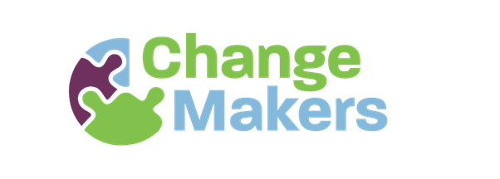
Project Worker (Part-Time, Specific Purpose Contract)
About ChangeMakers Donegal
ChangeMakers Donegal promotes global action at a local level. Funded by Irish Aid, the project began in 2012 and is an award-winning partnership between Inishowen Development Partnership, Donegal ETB, Self Help Africa, Trócaire, and Concern.
We work with adults across Donegal to explore global citizenship issues through workshops, accredited learning, community arts, environmental projects, and sustainability training. We also run the Seeds of Change grants and mentoring programme and work with a panel of facilitators to deliver workshops to raise awareness and take action to support fairer, more sustainable communities.
About the Role
IDP as lead partner on the ChangeMakers project is seeking a part-time Project Worker to support the delivery of ChangeMakers’ education and community action programmes.
This role suits someone with experience in community development and/or global citizenship education, who enjoys working with diverse groups and has strong coordination and planning skills.
The post is part-time (3 days per week, Tuesday–Thursday, 9am–5pm) and based at Inishowen Development Partnership, Buncrana. The contract is to December 31, 2026 but may be extended subject to funding.
Key Duties and Responsibilities
Programme Design & Delivery
- Deliver community projects and educational activities that support awareness, skills development, and collective action.
- Support the Project Coordinator, Steering Group, and facilitators in delivering the ChangeMakers programme, which includes accredited training and workshops, community conversations series, Grants for community groups, mentoring programmes, film club, and cross-sectoral and cross-community partnerships.
- Lead delivery of key initiatives, including the Seeds of Change grants and mentoring programme, working with mentors/facilitators, community groups, and community partners to see successful change projects linked to the SDGs implemented each year.
- Manage and develop the Sustainability Passport programme, including participant recruitment, mentoring, networking, digital resource updates and following up with participants to produce a pipeline of positive stories for the Sustainability Stories campaign.
- Oversee related administration, finance, facilitator engagement, reporting and website updates for each programme.
- Support the Project Coordinator in the planning and delivery of the annual ChangeMakers seminar.
- Develop and update clear, accessible learning resources for community use.
Reporting & Impact
- Support delivery of annual targets in line with Irish Aid requirements, budgets, and timelines.
- Attend Steering Group meetings and complete assigned actions.
- Track and report on weekly and monthly activities with the Project Coordinator.
- Implement monitoring and evaluation for activities and prepare regular reports.
- Assist with annual reporting to funders and partners, following the Irish Aid Results Framework and IDEA Code of Good Practice.
Marketing & Communications
- Support marketing and communications with the Project Coordinator and IDP Communications Officer to grow engagement and visibility across Donegal.
Other Duties
- Contribute to relevant Community Development and Environmental Team initiatives within Inishowen Development Partnership, including funded projects to find alignment/collaboration opportunities.
- Carry out other reasonable duties agreed with the Project Coordinator, IDP Team Lead and wider Steering Group.
- Evening or occasional unsocial hours may be required.
Essential Criteria
- Minimum three years’ experience in community development/work or global citizenship (development education) or lifelong learning.
- Experience designing and delivering in-person and online events.
- Strong facilitation, presentation, and networking skills.
- Ability to work independently and as part of a team.
- Strong time management and organisational skills.
- Proven ability to deliver projects on time and within budget.
- Creative, proactive, and comfortable co-designing programmes.
Desirable Criteria
- Knowledge of community work, and sustainable or global development.
- Experience creating educational resources.
- Experience in NGO, civil society, or education sectors.
- Experience working with networks or membership organisations.
Application Process
Please submit a completed application form, CV, and cover letter to hr@inishowen.ie by Monday, March 2nd , 2026 at 1.00pm.
Interviews are expected to take place in person at Inishowen Development Partnership, Buncrana (F93EE39) on Thursday March 12th, 2026

