

INISHOWEN DEVELOPMENT PARTNERSHIP

Important

Instructions on completing application form electronically:

- Save the document to your computer
- Fill in all relevant text areas
- Save your application as you complete each section
- Once completed, attach the PDF to an email and return to ALONG with your CV and Cover Letter to hr@inishowen.ie

Note: Apple MAC users, do not use Preview to complete this form, thank you

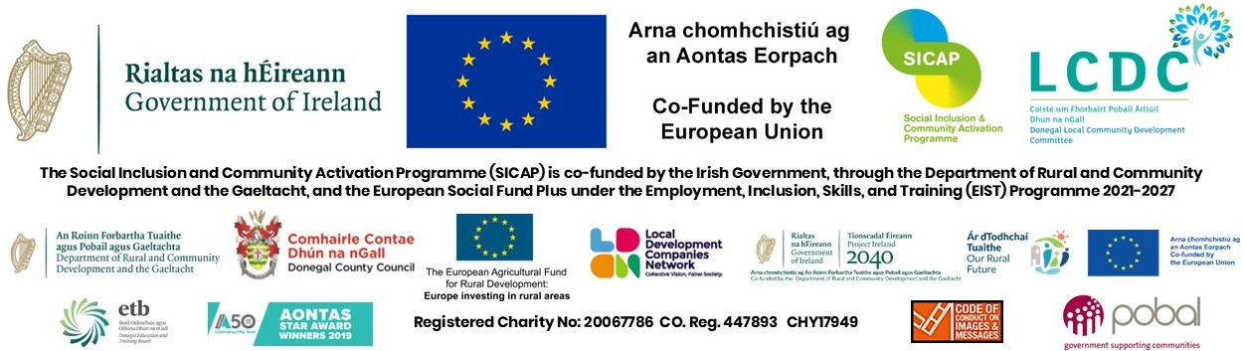

Community Development Officer

This Application Form, when completed, should be returned with your Cover letter and CV by email to hr@inishowen.ie

Closing Date: Monday, March 30th 2026 at 1:00pm
Proposed Interview date: Friday April 10th 2026

Surname (Block Capitals):- ____________________________________________________________________

First Name (Block Capitals):- ____________________________________________________________________

Address (for correspondence):-__________________________________________________________________

Permanent Address (if different) _________________________________________________________________

Telephone No:- Home: __________________________Work: ____________________________________

Mobile: _________________________ E-mail Address: ___________________________

Do you require any special facilities/arrangements if called for interview: YES/NO. If yes, please specify:_______________________________________________________________________________________

How did you hear about this position:

Word of Mouth Local Newspaper IDP Website IDP Job Club

Intreo Social Media(Facebook) ActiveLink

Do you hold a full driving licence? ____________________________________________________

Do you have access to a car? _____________________________________________

PARTICULARS OF EDUCATION

- EDUCATION/QUALIFICATIONS OBTAINED (Start with most recent)

School, College, University attended | Period  From To  (Please indicate if Full-Time or Part-Time) | Examinations taken indicating which level of Qualification e.g Level 7, 8 etc (with dates) | Results (Grade Obtained 1, 2.1 …Pass)

RECORD OF EMPLOYMENT EXPERIENCE TO DATE

Employer | Period of Employment  To From and Reason for Leaving | Position Held | Duties/Responsibilities
N.B. PLEASE COMPLETE PAGE NUMBERS 3 & 4 IN FULL.PLEASE ALSO SUBMIT A CURRICULUM VITAE

RECORD OF EMPLOYMENT EXPERIENCE TO DATE

Employer | Period of Employment  To From and Reason for Leaving | Position Held | Duties/Responsibilities

N.B. PLEASE COMPLETE PAGE NUMBERS 3 & 4 IN FULL.
PLEASE ALSO SUBMIT A CURRICULUM VITAE

Details of Relevant Experience

In relation to the employment record you have supplied please give details of your experience in the following areas. You should ensure that the example(s) you use is from a recent period in your employment which you feel most equips you for this position.
- What about the role of Community Development Officer aligns with your work experience to date? Please refer to any specific projects you have been involved in for particular target groups.

(ii) Give examples of your experience of community development work in the following areas: capacity building supports, facilitating groups, addressing social exclusion and inequality issues, governance compliance, network development and writing funding applications.

(iii) Please outline your experience in the following areas - community-based work, environmental work, and community education and training.

iv) Please indicate your experience in consultation and developing responses for community group needs outlining the steps involved and what you considered successful.

v) What is your awareness of the policy context for community development and social inclusion?

vi) Please outline your experience of supporting the development of interagency networks, what are the key elements in this work?

(vi) Level of IT Skills:
Please outline your ICT skills and experience e.g MS Office Suite; particularly MS Word, EXCEL, Access, and PowerPoint, and CRM systems you have used)

Please tick below to indicate competency with the following
 | No Knowledge | Basic Knowledge | Good Knowledge | Extensively Used
Databases (e.g. MS Access)
Accounting Package
File Management
Presentations ( e.g. powerpoint)
Social Media
Spreadsheets (e.g. MS Excel)
Website Management
Word Processing
Film/Media Production
Zoom/Teams

Period of Notice – How soon after an offer of employment could you take up employment?
_____________________________________________________________________________________
Do you require any of the following in order to work for this role?
(Please select all that apply.)
☐ A valid Irish work permit or employment permit (for non-EEA/UK/Swiss nationals)
☐ A Frontier (“cross-border”) Worker Permit to live in Ireland and work in Northern Ireland (or vice versa)
☐ Neither — I am a citizen or otherwise exempt and do not require such permission
PLEASE PROVIDE THE NAMES OF TWO RESPONSIBLE PERSONS AS REFEREES, TO WHOM YOU ARE WELL KNOWN BUT NOT RELATED. (IF YOU ARE IN EMPLOYMENT, ONE OF THE REFEREES SHOULD BE AN EXISTING EMPLOYER)
NAME:- ________________________ NAME:- ________________________________

ADDRESS:-_____________________ ADDRESS:- __________________________________
_____________________ __________________________________
____________________ _________________________________
Phone No. _______________________ Phone No. _________________________________
Email Address:_____________________ Email Address:________________________________

Before signing this Form please ensure that you have replied fully to all questions.
I, the undersigned, HEREBY DECLARE, all the foregoing particulars to be true.

Signature of Applicant: __________________________________________________________

Date: ____________________________

PLEASE SUBMIT YOUR CURRICULUM VITAE
WITH THIS APPLICATION.
Candidates may be shortlisted on the basis of information given in this Application Form, Coversheet and CV.

** Closing Date: Monday, March 30th at 1:00pm.

All applicants should note that the proposed interview date proposed Interview date: Friday April 10th 2026. Salary scale for this position is €40,614. Shortlisting will apply and a panel may be formed.

Inishowen Development Partnership is an equal opportunities employer and welcomes applications from all sections of society. The appointment is subject to normal recruitment procedures including Garda/Police Vetting.

RECEIPT OF APPLICATION – Candidates who send their Applications & CVs by email should allow sufficient time to ensure receipt by IDP, not later than the latest date and time for acceptance.

N.B. CANVASSING BY OR ON BEHALF OF THE APPLICANT
WILL AUTOMATICALLY DISQUALIFY.

(vii) Additional/Relevant Information: Please use this section to detail any other information you feel would be relevant to your application. You are encouraged to include experience of any voluntary/unpaid activities that you have been involved in. If including qualifications, please state the date they were obtained and the grade /level achieved. Attach and label any additional sheets used.

