

INISHOWEN DEVELOPMENT PARTNERSHIP

Important

Instructions on completing application form electronically:

- Save the document to your computer
- Fill in all relevant text areas
- Save your application as you complete each section
- Once completed, attach the PDF to an email and return to ALONG with your CV and Cover Letter to hr@inishowen.ie

Note: Apple MAC users, do not use Preview to complete this form, thank you

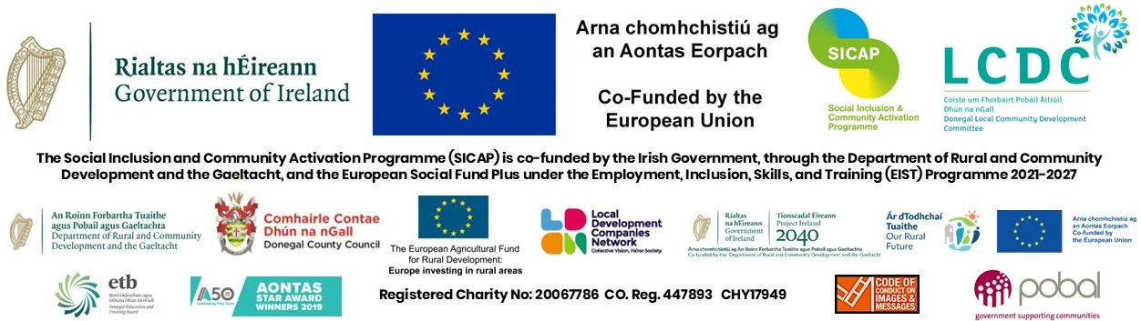

Enterprise Development Officer

This Application Form, when completed, should be returned with your Cover letter and CV by email to hr@inishowen.ie

Closing Date: Monday, April 30th at 12 noon
Proposed Interview date: Wednesday April 29th 2026

Surname (Block Capitals):- ____________________________________________________________________

First Name (Block Capitals):- ____________________________________________________________________

Address (for correspondence):-__________________________________________________________________

Permanent Address (if different) _________________________________________________________________

Telephone No:- Home: __________________________Work: ____________________________________

Mobile: _________________________ E-mail Address: ___________________________

Do you require any special facilities/arrangements if called for interview: YES/NO. If yes, please specify:_______________________________________________________________________________________

How did you hear about this position:

Word of Mouth Local Newspaper IDP Website IDP Job Club

Intreo Social Media(Facebook) ActiveLink

Do you hold a full driving licence? ____________________________________________________

Do you have access to a car? _____________________________________________

PARTICULARS OF EDUCATION

- EDUCATION/QUALIFICATIONS OBTAINED (Start with most recent)

School, College, University attended | Period  From To  (Please indicate if Full-Time or Part-Time) | Examinations taken indicating which level of Qualification e.g Level 7, 8 etc (with dates) | Results (Grade Obtained 1, 2.1 …Pass)

RECORD OF EMPLOYMENT EXPERIENCE TO DATE

Employer | Period of Employment  To From and Reason for Leaving | Position Held | Duties/Responsibilities
N.B. PLEASE COMPLETE PAGE NUMBERS 3 & 4 IN FULL.PLEASE ALSO SUBMIT A CURRICULUM VITAE

RECORD OF EMPLOYMENT EXPERIENCE TO DATE

Employer | Period of Employment  To From and Reason for Leaving | Position Held | Duties/Responsibilities

N.B. PLEASE COMPLETE PAGE NUMBERS 3 & 4 IN FULL.
PLEASE ALSO SUBMIT A CURRICULUM VITAE

Details of Relevant Experience

In relation to the employment record you have supplied please give details of your experience in the following areas. You should ensure that the example(s) you use is from a recent period in your employment which you feel most equips you for this position.
- Please describe how your previous work experience prepares you for the role of Development Officer for Lifelong Learning and Enterprise Development. In your response, outline any key projects or initiatives you have led or supported in adult learning, skills development, business start-ups, or enterprise growth

(ii) Please provide examples of your direct experience in enterprise development including work you have undertaken to build entrepreneurial and skills‑development capacity, mentor or support start‑ups, address barriers to participation, and ensure good governance and compliance.

(iii) What experience do you have in coordinating accredited and non-accredited training or professional development programmes, and how would you promote strong uptake and the practical application of learning across diverse target groups

iv) Please outline your experience in engaging with small businesses to assess their needs and in designing appropriate enterprise supports. Describe the key steps you follow in this process and how you evaluate the success of the supports provided

v) What do you consider to be the main challenges facing small businesses in the current economic climate, and how would you use this understanding to inform your approach in this role

vi) Please describe your understanding of the business support ecosystem, including awareness of regional and national agencies, networks, and policy frameworks that influence enterprise development

(vi) Level of IT Skills:
Please outline your ICT skills and experience e.g MS Office Suite; particularly MS Word, EXCEL, Access, and PowerPoint, and CRM systems you have used)

Please tick below to indicate competency with the following
 | No Knowledge | Basic Knowledge | Good Knowledge | Extensively Used
Databases (e.g. MS Access)
Accounting Package
File Management
Presentations ( e.g. powerpoint)
Social Media
Spreadsheets (e.g. MS Excel)
Website Management
Word Processing
Film/Media Production
Zoom/Teams

Period of Notice – How soon after an offer of employment could you take up employment?
____________________________________________________________________________________
Do you require any of the following in order to work for this role?
(Please select all that apply.)
☐ A valid Irish work permit or employment permit (for non-EEA/UK/Swiss nationals)
☐ A Frontier (“cross-border”) Worker Permit to live in Ireland and work in Northern Ireland (or vice versa)
☐ Neither — I am a citizen or otherwise exempt and do not require such permission

PLEASE PROVIDE THE NAMES OF TWO RESPONSIBLE PERSONS AS REFEREES, TO WHOM YOU ARE WELL KNOWN BUT NOT RELATED. (IF YOU ARE IN EMPLOYMENT, ONE OF THE REFEREES SHOULD BE AN EXISTING EMPLOYER)
NAME:- ________________________ NAME:- ________________________________

ADDRESS:-_____________________ ADDRESS:- __________________________________
_____________________ __________________________________
____________________ _________________________________
Phone No. _______________________ Phone No. _________________________________
Email Address:_____________________ Email Address:________________________________

Before signing this Form, please ensure that you have replied fully to all questions. I, the undersigned, HEREBY DECLARE, all the foregoing particulars to be true.

Signature of Applicant: __________________________________________________________
Date: ____________________________

PLEASE SUBMIT YOUR CURRICULUM VITAE
WITH THIS APPLICATION.
Candidates may be shortlisted on the basis of information given in this Application Form, Coversheet and CV.

** Closing Date: Monday, April 20th at 12noon

All applicants should note that the proposed interview date proposed Interview date: Wednesday April 29th 2026. Salary scale for this position is €40,614 pro rata. Shortlisting will apply and a panel may be formed.

Inishowen Development Partnership is an equal opportunities employer and welcomes applications from all sections of society. The appointment is subject to normal recruitment procedures including Garda/Police Vetting.

RECEIPT OF APPLICATION – Candidates who send their Applications & CVs by email should allow sufficient time to ensure receipt by IDP, not later than the latest date and time for acceptance.

N.B. CANVASSING BY OR ON BEHALF OF THE APPLICANT
WILL AUTOMATICALLY DISQUALIFY.

(vii) Additional/Relevant Information: Please use this section to detail any other information you feel would be relevant to your application. You are encouraged to include experience of any voluntary/unpaid activities that you have been involved in. If including qualifications, please state the date they were obtained and the grade /level achieved. Attach and label any additional sheets used.

