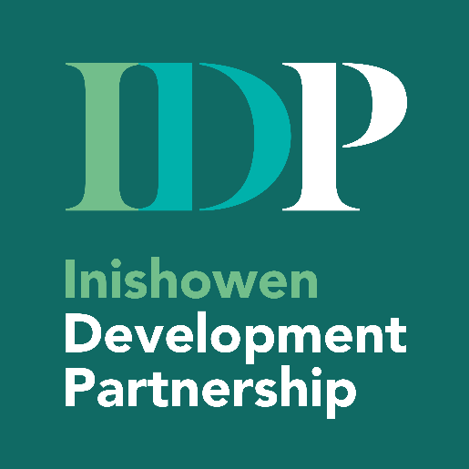

Invitation Document
Establishment of Multi-Supplier Facilitator Panels
(Multi-Lot Framework)

Inishowen Development Partnership (IDP)
12 Main Street,
Buncrana, Inishowen,
Co. Donegal,
F93 EE39
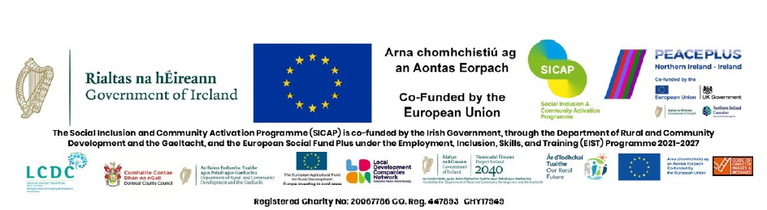
Email: christina@inishowen.ie

Introduction
Inishowen Development Partnership (IDP) is an integrated, community-led local development company delivering social inclusion and rural development programmes in the Inishowen peninsula for the past 30 years. IDP is a not-for-profit, community-based organisation that delivers a wide range of mainly Government-funded programmes aimed at tackling poverty, promoting social inclusion, and supporting community and economic development in the region. The stated values of the organisation are that we promote community-led, sustainable local development built upon the values of integrity, connectedness, innovation, and inclusivity.

Specification
IDP invites tenders from suitably qualified individuals and organisations to form a panel of suitably qualified and experienced facilitators who may be engaged to deliver programmes funded through the SEUPB HARC PEACEPLUS, LCDC PEACEPLUS, Changemakers PEACEPLUS, Sláintecare Healthy Communities Programme, and other national or EU initiatives. The panels will support the delivery of community-based programmes on a call-off, as-needed basis.

The tender is divided into five lots:
LOT no | Description
1 | Community Food & Nutrition – Community Facilitator Panel  Facilitators to deliver community-based healthy eating programmes, including:  - Cooking demonstrations  - Budgeting and meal planning and reducing food waste  - Food skills development  - Wellbeing-focused nutrition interventions
2 | Health & Wellbeing Facilitator Panel  Facilitators with experience in:  - Mental health promotion  - Fitness/ Physical activity programmes  - Self-care and building resilience  - Holistic wellbeing in community settings  - Outdoor activities
3
  Nature & Animal-Assisted Activity Panel  Practitioners qualified to deliver:  - Equestrian-based activities  - Animal-assisted interventions  - Therapeutic or engagement-based programmes  - Nature-based therapeutic activities | Additional requirements:  - Appropriate insurance  - Animal welfare compliance
4 | Heritage, Trades, Skills and Lived Experience Learning Contributors Panel  Facilitators and contributors with:  - Heritage, cultural or traditional skills  - Horticulture & Biodiversity  - Lived experience relevant to programme themes  - Ability to support community engagement and storytelling
5 | Skilled panel to assist social enterprises:  Facilitators and contributors with:
  - Human Resources  - Governance  - Volunteering  - CSR  - Community/ SE Business development  - Interpersonal & Management Skills  - Community/ SE Business startup guidance (not training) | - Health & Safety  - IT Skills  - Development Education  - Photography  - Project Management  - Strategy development
Suitably qualified individuals and organisations are invited to complete appendix 1 (attached) stating clearly which lot they are tendering for to deliver within the Inishowen area. The information submitted will be used to create a framework of suitable facilitators within each lot.
Time table:
It is anticipated that the Framework Agreement will commence in June 2026 and will be established for an initial period of one year, with the option, at the sole discretion of the IDP, to extend for up to 3 additional one-year periods, subject to funding and satisfactory performance.

Value of the Contract:
Appointment to a panel does not guarantee any volume or frequency of work.
The total value of the contract will be determined by how many times a facilitator has been chosen from the framework. All fees stated shall be deemed to be inclusive of all costs, preparation time, expenses, and taxes unless otherwise stated.

Payment:
Payments will be made once each programme event or activity block has been completed.

Evaluation / Award Criteria:
A two stage process will be used to assess tenders.
Stage 1- Selection (Minimum Qualification) Criteria
Stage 1 of the assessment process will assess minimum requirements of facilitators.
Selection Criteria | Mark
The facilitator shall demonstrate the minimum requirements:  Qualifications & Experience:  - Relevant qualifications &/ or experience (where applicable)  Tax Compliance:  - Tenderers must be fully tax compliant. Evidence: Valid Tax Clearance Certificate, Tax Reference Number [TRN], Tax Clearance Access Number [TCAN] (or equivalent, where applicable).  Professional Indemnity Insurance (PII) :  - Hold suitable professional indemnity insurance (If relevant) | Pass/Fail  Pass/Fail  Pass/Fail
Tenderers who demonstrate the minimum requirements will receive a pass mark and move on to stage two.

Stage 2 –Award Criteria
All tenderers will be assessed against the cost evaluation criteria listed within this section.
Selection Criteria | Mark
Cost  Applicants’ proposed rates will be evaluated on a value for money basis, having regard to the scope and nature of the services offered and prevailing market conditions. While cost is the sole award criterion, the evaluation will not be based solely on the lowest price submitted. | 100%

Panel Arrangement and Call-Off of Services
Following evaluation, the IDP intends to establish a multi-supplier panel for each Lot comprised of all applicants who meet the minimum requirements and achieve the minimum qualifying score under the award criteria.
Services will be awarded on a call-off basis during the term of the panel. Subject to operational requirements, call-offs will be allocated on a rotational basis among panel members within the relevant Lot.

The establishment of a panel does not imply any commitment as to the volume, frequency, or value of services to be awarded. The IDP reserves the right to allocate services outside of the rotation where objectively justified, including but not limited to urgency, continuity, performance, specialist expertise, or capacity considerations.
The contract established through this tender shall be a Framework Agreement setting out the terms, conditions, and pricing for the provision of the specified services. The execution of this contract does not constitute an order for any specific quantity or volume.
The IDP reserves the the right, at its discretion and in accordance with applicable procurement principles to:
- Withdraw or Cancel this Tender process at any time, for any reason, without prior notice.
- Reject all submissions received, even if they meet the minimum criteria and specifications set forth in this document.
- Decline to award a Contract to any Tenderer, even the lowest-priced or highest-scoring bidder, if the Buyer determines that doing so is in its best interest.
- Suspend or modify the procurement schedule, specifications, or process.
In the event of cancellation, rejection of all submissions, or a decision not to award, the IDP shall incur no liability whatsoever to any Tenderer for any costs, expenses, losses, damages, or liabilities incurred by the Tenderer in the preparation or submission of its response. The issuance of this Tender does not constitute a commitment by the IDP to award a contract or to proceed with the procurement described herein.

Deadline for Tender Submissions
The deadline for submissions is 12 noon, Friday 22nd May 2026.
Submissions can be made either by e-mail to christina@inishowen.ie or by hard copy to
Christina Perry, PEACEPLUS Programmes Co-Ordinator,
Inishowen Development Partnership (IDP),
12 Main Street, Buncrana, Inishowen,
Co. Donegal, F93 EE39

Any queries please contact the PEACEPLUS Programmes Co-Ordinator Christina Perry via the following e-mail address christina@inishowen.ie

Appendix 1 – Facilitator Tender Information Form
Applicant Details
Name of Individual/ Organisation:
Trading name (if different):
Address:
Primary contact person:
Email Address:
Phone Number:

Lot /Lot(s) applied for (tick all that apply)
 | LOT | Name
☐ | 1 | Community Food & Nutrition – Community Facilitator Panel
☐ | 2 | Health & Wellbeing Facilitator Panel
☐ | 3 | Nature & Animal-Assisted Activity Panel
☐ | 4 | Heritage, Trades, Skills and Lived Experience Learning Contributors Panel
☐ | 5 | Skilled Panel

Minimum Requirements (please tick to demonstrate each are met)
☐ | I hold appropriate Professional Indemnity Insurance relevant to the services offered
☐ | I have relevant qualifications &/ or experience
☐ | I can provide evidence of Tax Compliance if requested
☐ | I have the capacity to deliver services within the Inishowen area

Skills, Experience & Areas of Expertise
(Briefly outline your relevant skills, experience, and any specialist areas – max 150 words)

Qualifications & Professional Background (Where applicable – brief summary)

Proposed Rates (Rates to include all costs)
Hourly rate | Half- Day rate  (up to 3.5 hours delivery excluding breaks)
€ | €
Optional notes on rates (if any):

Areas you can facilitate in:
 | Areas
☐ | Clonmany, Urris, Ballyliffin, Cloontagh & surround
☐ | Malin, Glengad, Malin Head & surrounds
☐ | Culdaff, Carrowmena, Gleneely & surrounding environs
☐ | Quigleys Point, Redcastle, Whitecastle & surrounds
☐ | Carndonagh & surrounds
☐ | Moville, Greencastle & surrounding environs
☐ | Burt, Inch, Fahan, Burnfoot & surrounds
☐ | Border villages- Muff, Carrigans, Killea, Bridgend, Newtoncunningham & surrounds
☐ | Buncrana Urban- Buncrana, Cockhill & surrounds
☐ | Buncrana Rural- Desertegney, Illies, Drumfries & surrounds
☐ | N/A - I am a fixed premises/ location

Any additional relevant information:

Declaration
I confirm that the information provided above is accurate and that I understand appointment to a panel does not guarantee any volume or frequency of work.
Signed:
Name:
Date:

